# Section 4: Charts and APIs

# Statistic of COVID19 Cases

### Download and install Power Bi Desktop

Download a Power Bi desktop from Microsoft site for Windows and install it by following screen instruction.

### Open Power Bi Desktop application and make a connection for Rest API

Go to Get Data 🡪 Web 🡪 Basic 🡪 URL 🡪 OK

We are required to display graph for Singapore, Hence selected only Singapore in URL.

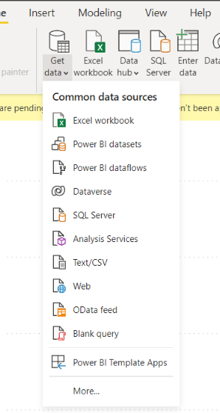

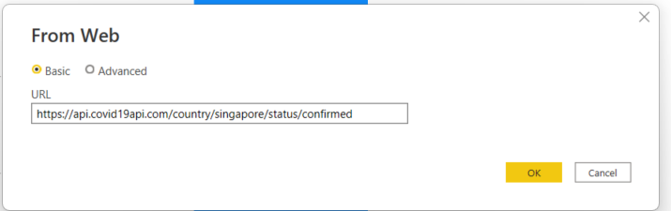

### Derive new column from Date like Month, Quarter, Year and Day etc.

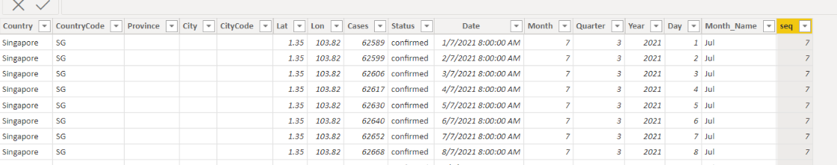

### COVID 19 cases over month using Line Cahrt

Here we have 3 years data, hence given a filter for year. Please choose year for which you would like to see the COVID 19 cases in Singapore over month

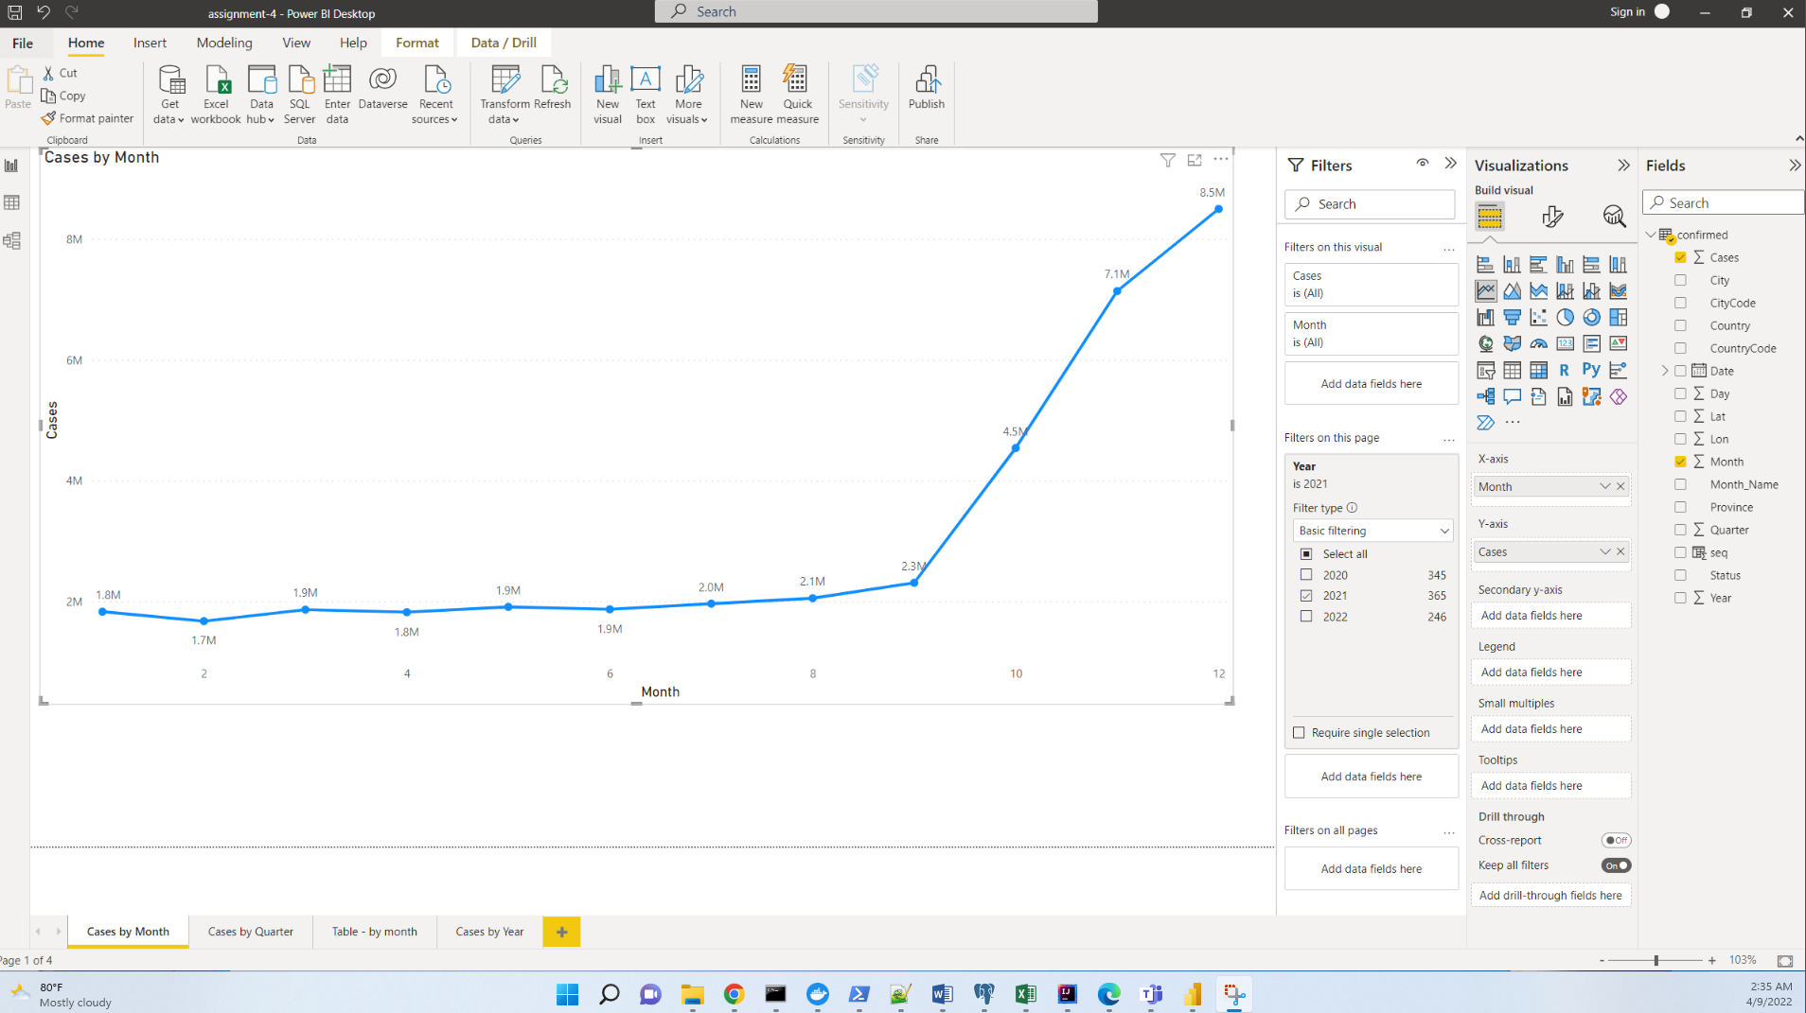

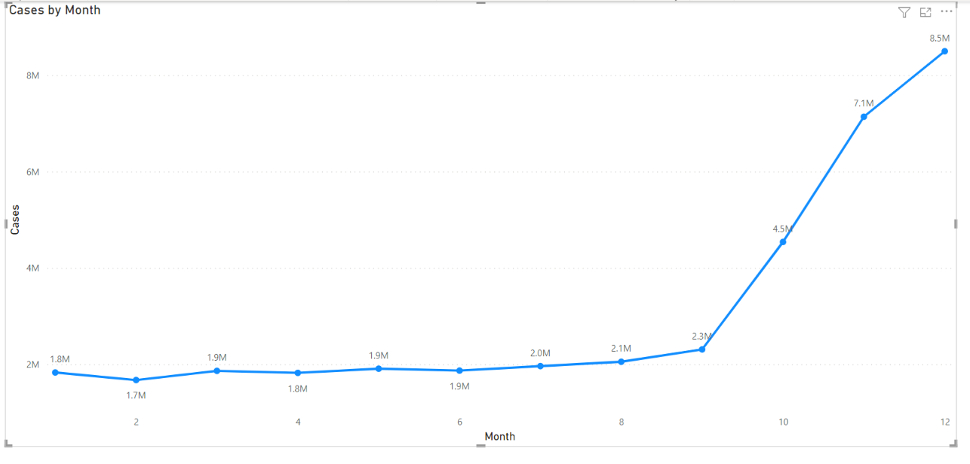

### COVID 19 cases over Quarter using Bar Chart

Please select year accordingly

